MT. KEARSARGE
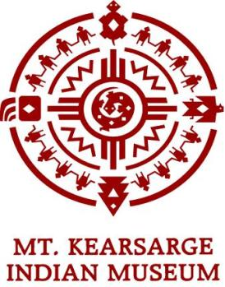
INDIAN MUSEUM
Indianmuseum.org
GROUP VISIT GUIDELINES

We look forward to welcoming you to the Mt. Kearsarge Indian Museum. These guidelines will help you make the most of your visit.

What To Bring
- Programs are rain or shine. Please wear appropriate clothing and comfortable shoes.
- Bring bug spray and water bottles. There are no water fountains.
- Due to stain and damage potential, no red drinks, candy or gum are allowed in the museum.
- Picnic tables are available outside and in our barn for your use.
- The Museum is a CARRY IN - CARRY OUT facility, so remember to bring your trash bag(s).
- Please have your group wear name tags. We like to use guests’ names when they ask questions.
- We have an excellent Museum Store that is included in the tour. We suggest that the children be given the opportunity to make a purchase as a reminder of their visit. There are many quality items available for $5.00 or less.
During Your Visit
- Flash photography is not allowed inside Museum galleries.
- Please arrive 15 minutes before the start of your tour.
- One representative should come into the Museum to notify us of your arrival. This person should know the total number of students and chaperones and have payment ready.
- Teachers and chaperones are responsible for ensuring appropriate student behavior with regard to the Museum’s collections, grounds, and staff. Any disciplinary issues should be handled in accordance with your institution’s guidelines.
- During your tour, your students will be given the opportunity to smell and/or touch natural materials. It is the responsibility of teachers or chaperones to notify your tour guide of any allergy issues with your students.
Cancellation Policy
- Please notify the Museum no later than 72 hours prior to arrival if your group number alters by more than 10 from your confirmed reservation.
- Please notify the Museum of cancellation or delay as soon as possible. We will make every effort to accommodate your group. There is a $50.00 cancellation fee if less than 48 hours notice is received. This excludes cancellations due to school closure or extreme weather conditions.
Directions
- From Rte 89N: take exit 8, L at end of ramp, R onto Rte.103 (E. Main St.), then 1 mile to the center of Warner. Turn right at the bank onto Kearsarge Mountain Road. We are one mile on the right.
- From Rte 89S: take exit 9, L at end of ramp onto Rte. 103 East, then 1.5 miles to the center of Warner. Turn left at the bank onto Kearsarge Mountain Road. We are one mile on the right.

18 Highlawn Rd. P.O. Box 142 Warner, NH 03278 603-456-2600 indianmuseum.org

rev.7/12 ED

